INTEGRATED OFFICE SCORECARDS

A PROJECT REPORT

Submitted by

MADHAN JOY DENISTAN

...

in partial fulfillment for the award of the degree

of

BACHELOR OF ENGINEERING

in

COMPUTER SCIENCE

XXX ENGINEERING COLLEGE, KANCHEEPURAM

ANNA UNIVERSITY:: CHENNAI 600 025

MAY 2008

ANNA UNIVERSITY : CHENNAI 600 025

BONAFIDE CERTIFICATE

Certified that this project report “…. INTEGRATED OFFICE SCORECARD ….”
is the bonafide work of “…………..MADHAN JOY DENISTAN.…………” who carried out the project work under my supervision.

SIGNATURE SIGNATURE

HEAD OF THE DEPARTMENT SUPERVISOR

ABSTRACT

This software aims to reduce the gap between employees and business by providing metrics to measure the power and contribution of each employee in the growth of an organization and using these metrics provide a justified method of rewarding talents and a scientific approach to grow and nurture talent in the organization. Scorecard is similar to a progress report card. Through an exercise, each entity in an organization is given a rank on the scores gained in a set of measures similar to a student being ranked on the marks he gained in a set of subjects. These scorecards will be integrated to provide a final integrated scorecard for an employee, for a team, project, division and the company as a whole.The system comprises of four scorecards explained below.

Balanced Scorecard: The Balanced Scorecard is a management concept that says there is/should be more that one imperative for success. At high level it considers success, or effectiveness, to be a balance across financial, strategic, customer and internal process compliance. In most organizations goals of the individuals are not aligned to the goals of the organization. This scorecard provides an approach, by which each individual is aligned to the goals of the organization, everyone performing towards a single goal.

Competency Scorecard: This scorecard measures the skill levels of each entity in the organization and provides a systematic way to develop talent in the organization. If the skill level of each employee is measured through a well defined system, then it is possible to expect the performance of a team or a division for performing a special task.

Performance Scorecard: This subsystem implements the performance appraisal system in an organization and attempts to eliminate various flaws usually found in the normal appraisal process. This is a system which measures the performance of employees in the last appraisal period, consolidates inputs from the employee and their managers and derives a score by which the employee is rewarded. Another advantage is that high performing teams can be identified and rewarded. Out of performance scorecard, a score, a numerical result will be given to each entity in the organization.

Integrated Scorecard: The scorecards mentioned above obtain their full power when consolidated. The competency scorecard provides a way to see what an employee is capable of, and makes provision to grow the talent. The balanced second makes sure that each employee’s performance is aligned to the goal of the company and so growth of each employee feeds the growth of the company. Performance scorecard sees what the employee has done in the past period, and tracks his growth over the past period. When integrating these three scorecards a final scorecard called “Integrated scorecard” is derived.
ABSTRACT 3
LIST OF TABLES 7
LIST OF FIGURES 8
LIST OF SYMBOLS, ABBREVIATIONS AND NOMENCLATURE 9
1.INTRODUCTION TO IOS 10
1.1.Balanced Scorecard 11
1.1.1.Strategy, Mission and Vision 11
1.1.2.Perspective 11
1.1.3.Objectives, Measures, Targets, and Initiatives 12
1.2.Competency Scorecard 15
1.3.Performance Scorecard 16
1.4.Integrated Scorecard 18
2.PROBLEMS IOS ATTEMPT TO SOLVE 19
3.IOS REQUIREMENTS 21
.1Need for Defining Requirements Explicitly 21
Summarized Requirements list for IOS 21
Detailed Requirements for IOS 30
First logon 30
Global Parameters 31
System Roles 32
Access rights and menus 33
Setting up Organization Hierarchy 34
Setting up Organizational Roles/positions 35
Managing users in the organization 36
Period of scorecard exercise Definition 38
Scorecard types 41
User Classes and Characteristics 42
Operating Environment 43
4.IOS ARCHITECTURE (DESIGN) 44
IOS High Level Design 45
The major subsystems of the main system 45
The Interactions between the subsystems 46
Low Level Design 48
Subsystem Designs 48
Database SubSystem 48
User Interface Subsystem 54
User Interface 55
Set Up Sub System 59
Introduction 59
Competency management system 62
Balanced scorecard management system 66
Integration management system 69
Performance Management System 72
Development Life Cycle 76
Exception Handling 76
Development Process 76
5.IOS CONSTRUCTION (DEVELOPMENT) 77
6.APPENDIX 1 104
7.REFERENCES 105

LIST OF TABLES

Table 1: Summarized Requuirements List 29
Table 2: First Logon 31

LIST OF FIGURES

Figure 1: IOS Conceptual View 10
Figure 2: Vision and Strategy 12

LIST OF SYMBOLS, ABBREVIATIONS AND NOMENCLATURE

IOS | Integrated Office Scorecard
BS | Balanced Scorecard
.NET | Visual Studio .NET
CAS | Competency Assessment Scorecard
PS | Performance Scorecard
IS | Integrated Scorecard

INTRODUCTION TO IOS

The goal of the project is to develop a system to help organizations track their performance, growth, strengths and targets using a set of scorecards such as the competency scorecard, balanced scorecard and performance scorecard. Scorecard is similar to a progress report card. Through an exercise, each entity in an organization is given a rank on the scores gained in a set of measures similar to a student being ranked on the marks he gained in a set of subjects. These scorecards will be integrated to provide a final integrated scorecard for an employee, for a team, project, division and the company as a whole. Using the data derived from these scorecards so much of valuable information can be collected by the management to set up strategies that will spearhead the organization to perform at its highest potential to achieve the desired targets, mission and vision. This software aims to reduce the gap between employees and business by providing metrics to measure the power and contribution of each employee in the growth of an organization and using these metrics provide a justified method of rewarding talents and a scientific approach to grow and nurture talent in the organization.

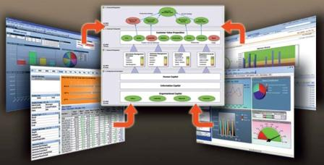
Figure 1: IOS Conceptual View

The system comprises of four scorecards explained below.

Balanced Scorecard
The Balanced Scorecard is a management concept that says there is/should be more that one imperative for success. At high level it considers success, or effectiveness, to be a balance across financial, strategic, customer and internal process compliance. Robert Kaplan and David Norton have invented this method in 1992. The main use of this scorecard is to have a mechanism, by which the growth of an organization can be measured in the correct way. Most organizations fail to perform in its best not because of bad performance, but everyone performing best for himself, for his growth, for his teams growth, while not concentrating whether his performance is helping the organization growth. Simply put, goal of the individuals are not aligned to the goals of the organization. This scorecard provides an approach, by which each individual is aligned to the goals of the organization, everyone performing towards a single goal. From this scorecard also each entity will get a score out of this scorecard, which will be compared against the ideal score.

Strategy, Mission and Vision

At the top, the management designs the strategy of an organization. It designs the mission and vision of an organization. Mission is the method of operation of the business. How the company should operate, what are its values that the company treasures. Vision is what the company sees itself in the future. Something like being the top hospital in India in 10 years, to be the most sought after IT solutions provider in business intelligence etc. Then the perspectives (dimensions) in which the company should concentrate to achieve its goals are decided.

Perspective

Traditionally organizations concentrated only on the financial growth. But when other areas are not concentrated the financial growth usually reduces gradually. Various researches have given indication that organizations need to concentrate on a few other dimensions to grow in the right manner. The four most important dimensions, called as perspectives in balanced scorecard terminology are financial perspective, Customer perspective, business process perspective and Learning & growth perspective.
The four perspectives are interlinked. When learning & growth in an organization improves, employees are empowered to improve their business processes. When business processes improve, better products are produced, and better customer management structures are defined. This results in happy and satisfied customers. With more and more satisfied customers, the profit or the financial of the company grows. As a chain, with more financial growth, learning & growth improves and so on.

The Financial Perspective
Kaplan and Norton do not disregard the traditional need for financial data. Timely and accurate funding data will always be a priority, and managers will make sure to provide it. In fact, there is often more than sufficient handling and processing of financial data. With the implementation of a corporate database, it is hoped that more of the processing can be centralized and automated. But the point is that the current emphasis on financial issues leads to an unbalanced situation with regard to other perspectives. There is perhaps a need to include additional financial related data, such as risk assessment and cost benefit data, in this category.

The customer perspective
Recent management philosophy has shown an increasing realization of the importance of customer focus and customer satisfaction in any company. These are called leading indicators: if customers are not satisfied, they will eventually find other suppliers that will meet their needs. Poor performance from this perspective is thus a leading indicator of future decline. Even though the current financial picture may seem (still) good. In developing metrics for satisfaction, customers should be analyzed. In terms of kinds of customers, and of the kinds of processes for which we are providing a product or service to those customer groups.

The Business Process perspective
This perspective refers to internal business processes. Measurements based on this perspective will show the managers how well their business is running, and whether its products and services conform to customer requirements. These metrics have to be carefully designed by those that know these processes most intimately.

Learning and Growth perspective
This perspective includes employee training and corporate cultural attitudes related to both individual and corporate self-improvement. In a knowledge worker organization, people are the main resource. In the current climate of rapid technological change, it is becoming necessary for knowledge workers to learn continuously. The integration of these four perspectives into a one graphical appealing picture has made the Balanced Scorecard method very successful as a management methodology.

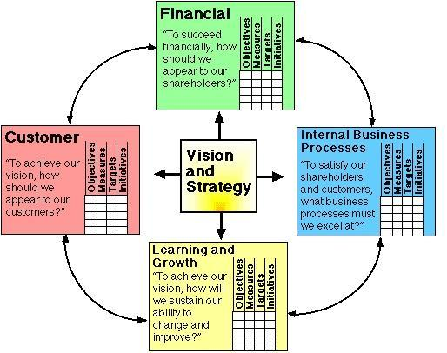
Figure 2: Vision and Strategy

Objectives, Measures, Targets, and Initiatives

Each perspective in balanced scorecard contains a few elements such as objectives, measures, targets and initiatives which are tracked
Objectives: major objectives to be achieved, for example, profitable growth.
Measures: the observable parameters that will be used to measure progress toward reaching the objective. For example, the objective of profitable growth might be measured by growth in net margin.
Targets: the specific target values for the measures, for example, 7% annual decline in manufacturing disruptions.
Initiatives: projects or programs to be initiated in order to meet the objective.

The table below shows a sample balanced scorecard.

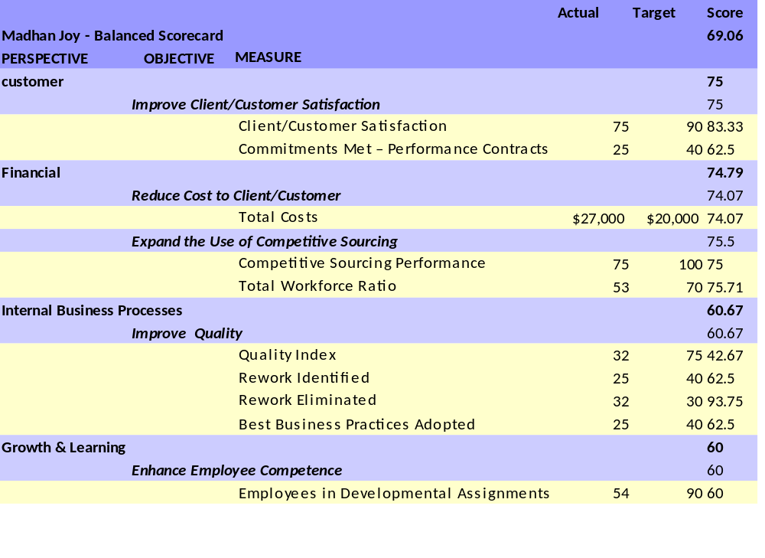

Competency Scorecard
Put simply, this scorecard measures the skill levels of each entity in the organization. This is of high interest to every management, as an organization cannot perform in its highest potential if the management does not know the strengths and weaknesses of its people. If the skill level of each employee is measured through a well defined system, then it is possible to expect the performance of a team or a division for performing a task. Also with a task at hand, the management can collect a team of persons who has the skills to complete that task. If a task that requires highly experienced sales persons and if it is assigned to inexperienced employees, the chance of expected success is highly doubtful.

There are so many other advantages for measuring the competencies. Each employee is given a chance to know his strengths and weaknesses. The employee and his manager can set up a training plan to improve his weak areas and to specialise further in his strong points. The initial skill levels of an employee can be compared with his growth, and with the growth percentage the rewarding of an employee can be correctly determined. There are so many other information that the management can derive from this data such as analysing the strength of a competency organization wide, how many employees that require a certain skill, lack it so that they can be trained, search the employees who have the highest proficiency for a particular skill, the list goes on.

Below is a sample competency Scorecard.

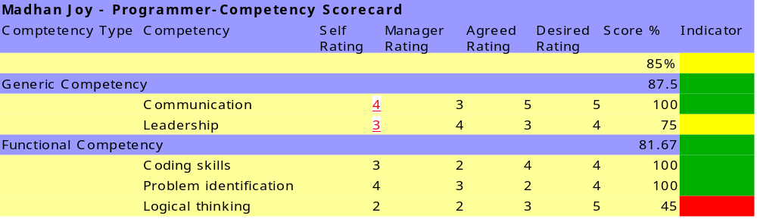

Performance Scorecard

This subsystem implements the performance appraisal system in an organization and attempts to eliminate various flaws usually found in the normal appraisal process. This is a system, which measures the performance of employees in the last appraisal period, consolidates inputs from the employee and their managers and derives a score by which the employee is rewarded. Also the action plans are set up by which the employee is given chance to improve his performance or use his expertise to train less experienced. This system also provides valuable input to the management by highlighting best performers, to be assigned important roles. Another advantage is that high performing teams can be identified and rewarded. Out of performance scorecard, a score, a numerical result will be given to each entity in the organization.

The system differs from similar systems in that the performance appraisal exercise in also done in a scorecard fashion. The performance of an employee in his previous appraisals is also considered while his rewarding is considered.

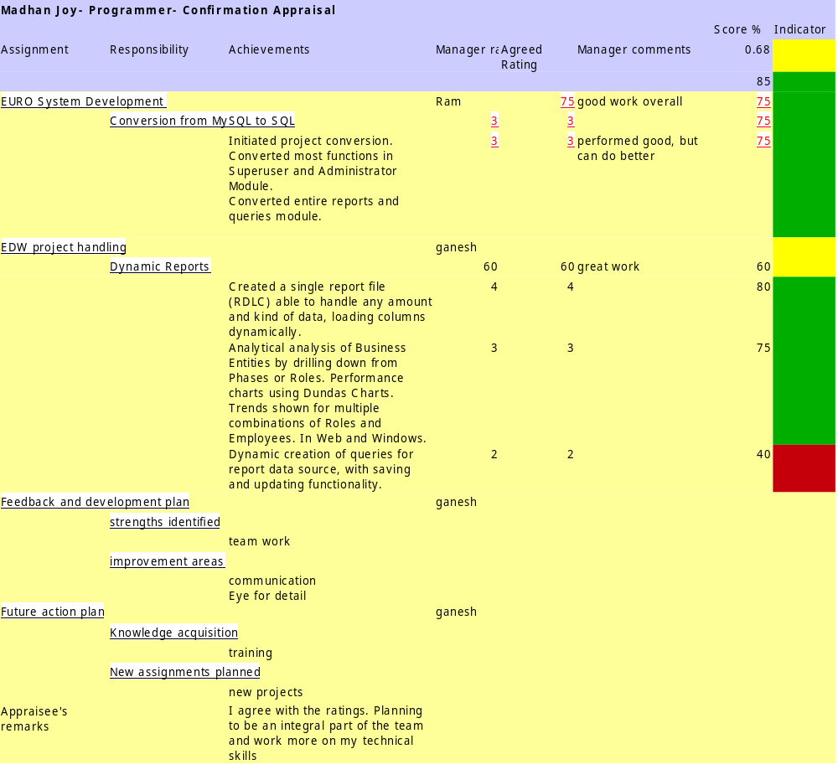

Integrated Scorecard

The scorecards mentioned above obtain their full power when consolidated. The competency scorecard provides a way to see what an employee is capable of, and makes provision to grow the talent. The balanced second makes sure that each employee’s performance is aligned to the goal of the company and so growth of each employee feeds the growth of the company, while it also allows the company to monitor its growth by monitoring a manageable set of measures for growth. Performance scorecard sees what the employee has done in the past period, and tracks his growth over the past period. When integrating these three scorecards a final scorecard called “Integrated scorecard” is derived. This integrated scorecard is an automatic scorecard that is derived using a set of simple rules such as what is the weight of competency score, balanced scorecard score and performance scorecard in deriving the final score. Each entity whether employee, team, division, branch will have a final score, by which future decisions will be taken by the management on growing an entity or assigning it important tasks.

Given below is an example of how the system modules are comprised to produce the integrated scorecard

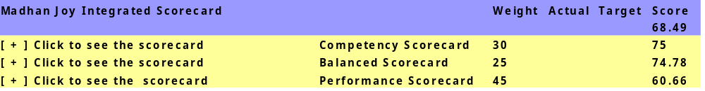

The system has the facility to configure these scorecards completely from scratch. Ie, The system will have facility to complete delete scorecard of say, type “Competency scorecard” and create it again. Any new scorecards can also be created apart from the above mentioned three scorecards and can be plugged into the integrated scorecard. But initially the system will have the three main scorecards preconfigured to use instantly.

PROBLEMS IOS ATTEMPT TO SOLVE

Need for Problem definition

A problem definition defines what the problem is without any reference to possible solutions. It’s a simple statement, and it should sound like a problem. The problem definition lays the foundation for the rest of the programming process. The penalty for failing to define the problem is that a lot of time can be wasted solving the wrong problem. This is a double-barreled penalty because the right problem is not solved either.

Problem definition comes before detailed requirements work, which is a more in depth investigation of the problem.

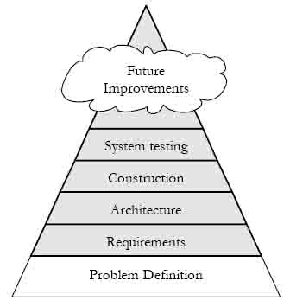

Problem Definition for IOS

Note: A common term “Entity” is used to identify each and every element in an organization. Whenever the term “Entity” is used, it means an employee, team, department, division, branch or even the organization as a whole itself.

After a comprehensive analysis it’s been found that there are various systems in the market to help organizations work in an intelligent manner. All such software belongs to a new domain called “business intelligence”. These software help organizations understand their business, predict the market and their own performance and help them perform better. The problem with these tools is that they are highly specialised, in that they require expensive hardware and software.

These softwares do not consider employees and business together. They monitor how the business is performing. But they forget about the employees who make the business. Or they take too much care of the employee not concentrating enough on the business. No software currently exists that track the growth and performance of employees and relate their performance to the growth of the business. They are separate packages whose valuable collective information is not yet realised. Hence the advantage that these combined modules can offer, remains unrealised.

Many a times, the rewarding of an employee or team is not done in the best manner. One who is famous with the manager is rewarded more, regardless of whether he is really a good performer or not. Also, just trying to assess the performance of an employee once in a year will not provide the correct result. This monitoring should be a continuous process, which the employee himself is clearly aware of, so that each and every employee will try to improve his performance day by day, resulting in a highly performing organization.

Another disadvantage found in such software is the complexity of operating. Most of these software demand so much expertise in business intelligence that take considerable amount of training to configure that most of the companies are reluctant to try such software. Also the companies that produce such software try to market an array of their other products along with this software that only very big organizations can afford such products.

The proposed system will eliminate these gaps. It will provide a consolidated state of each entity in an organization by combining three different scorecards to give various business intelligence reports to the management. It will be is simple to configure and manage, highly customizable and will be a simple standalone website that will not depend upon too many third party components or expensive packages.

- Most of the organizations do not practice a competency management system. Even those that manage do not have a highly robust system that can handle any kind of organization.
- The balanced scorecard used by most of the organizations is a highly complex system and is very expensive to manage. Many organizations do not use this either because of the complexity or the cost. A simple and inexpensive solution with capabilities to handle huge amount of operational data is not available.
- The performance appraisal systems in most of the organizations give more bad results than good. A system that manages performances throughout the year, with direct individual involvement is not available. A performance appraisal system which rewards the individuals in a very justified and honest manner is not available.
- The performance of an entity in an organization depends upon the performance of so many other entities. A system to view and manage how an entity’s performance is affected positively or negatively by the performance of other entities is not available.
- Usually decision is taken on an entity’s performance, but taking into consideration only one side of the performance. A method is required by which the competencies, growth of competencies, goal alignment of an entity to the organization’s goal, growth of goal alignment, performance of an entity and its performance growth are considered to give a final verdict of the performance. Also, an organization might want to measure performance using a totally new scorecard, or it might want to measure using only one scorecard instead of three or four scorecards. A system that is flexible enough to handle, 1, 2 or any number of scorecards to assess an entity’s performance is not available.

IOS REQUIREMENTS

Need for Defining Requirements Explicitly
Requirements help to ensure that the user rather than the programmer drives the system’s functionality. If the requirements are explicit, the user can review them and agree to them. If they’re not, the programmer usually ends up making requirements decisions during programming. Explicit requirements keep you from guessing what the user wants.

Explicit requirements also help to avoid arguments. You decide on the scope of the system before you begin programming. If you have a disagreement with another programmer about what the program is supposed to do, you can resolve it by looking at the written requirements. Paying attention to requirements helps to minimize changes to a system after development begins.

Specifying requirements adequately is a key to project success, perhaps even more important than effective construction techniques. If a good requirements work hasn’t been done, you might have missed important details of the problem. Requirements changes cost 20 to 100 times as much in the stages following construction as they do earlier, so it’s always best that the requirements are right before programming starts.

Summarized Requirements list for IOS

Req No | Req Name | Detail
Setup1 | First logon | System should be able to identify if it is the first time use. System should immediately take the user to a screen where employee creation is done. A user id and password should be created. System should ask the user to confirm the password. System will inform the user that he is a super user. After successful creation, the system takes the user to the login page where he will use his just created user name and password to login to the system. This will take him to the main page where links to all operations that he can perform will be shown to him.
Setup2 | Global Parameters | The system should have provision to use global parameters. By default the system will have the global parameters explained below  the date display format ( What is the format of date the system will display)  the number of decimal values ( How many decimal points a number should display)  Once configured, the system will always use the value of global parameters throughout.
Setup3 | System Roles | The roles of people who will be using the system. This is different than the organizational roles like manager, programmer etc. This defines the different types of people who will be using this system. super users, Administrators, Application users are the different users who will be using IOS.
Setup4 | Access rights and menus | Depending upon the user and his current status, the menus should be displayed. Also if a user plays multiple system roles, all the common operations for all these roles should be available to the user.
Setup5 | Setting up Organization Hierarchy | System should have the provision to set up the complete organization hierarchy. Organization hierarchy means setting up the head office, branches etc. Any level of hierarchy should be allowed in the system and it should be flexible enough to let administrators assign names to each entity of the organization hierarchy. As an example administrator will decide whether to call it a branch or division.  For the sake of simplicity, all the divisions, departments etc will be called by the common name “Entity”.
Setup6 | Setting up Organizational Roles/positions | System should be able to set up roles inside the organization. No hierarchy should be used while defining roles. System does not need to create hierarchies with the roles. System should provide options to give some descriptions to the role.  All the organization roles should be allowed to be viewed, modified, deleted.
Setup7 | Managing users in the organization | The Administrator in each division or department will be inputting a few key user information.  The username of the user, Email id ,Should he undergo the scorecard exercises, type of user,The organizational role of the employee and the person he is reporting to.  Title, First Name, Last Name, Email Id, Gender. Organizational hierarchy and mandatory custom properties. To select the organizational hierarchy, the user should be able to select any level starting from the top level of the hierarchy and filtering through the lowest level; or he can just select the lowest level he belongs and the system loads the upper level hierarchies automatically.
Setup8 | Period of scorecard exercise Definition | The period of exercise (from when to when the exercise is to be performed) should be configurable in the system.  For each exercise period, another date which indicates for which period the exercise is performed should be mandatorily given.  As an example, the performance scorecard exercise to be performed from 12-Apr-2007 to 10-May-2007 is to consider the performance of employees for the year Apr-2006 to Mar-2007.
Setup9 | Scorecard types | The system will have option to modify a scorecard type. System will also provide options to attach descriptions to the scorecard type. As an example “Comptency scorecard” can be called as “Skill card” This is not the scorecard name. There can be many scorecards with a scorecard type. For example “Competency scorecard” is a scorecard type. “Developer competency scorecard”, “Sales man competency scorecard” is a few scorecards of type “Competency scorecard”.
CAS1 | Scoring methods | System should maintain scoring methods that will contain the logic for calculating the scores of users as a result of a scorecard exercise. By default the only scoring method system will maintain will be simple average. But system should have the provision to include new scoring methods. Each scoring method will be included in the system as a business object and the scoring logic should be included in the business object.Also applicable for other scorecards.
CAS2 | Assessor types | An employee will be assessed by himself and his manager.Also applicable for other scorecards.
CAS3 | Assessment Phases | The phases are employee phase, manager phase and agreed phase.Only the super user can start these phases. Employee rating and agreed rating can be started at the same time, but agreed rating will begin only after the the above two phases are completed.
CAS4 | Competency types | Competency types are used to group competencies. An example of competency type may be “general competencies”. Communication competencies, team work are examples of generic competencies. Another competency type is “job specific Competencies”. Proficiency in sales, people management, and expertise in computer networks is competencies very specific to a job.
CAS5 | Competencies | A few examples of common competencies that need to be measured in an organization is understanding the Business, Technical Knowledge, Work Coordination, Problem Solving and Prevention, Communication and Service, Accountability. System should be able to let the administrators create, modify and delete the competencies. Each competency should be tied with a competency type. If a competency has been used in previous exercises, then the competency cannot be deleted.Each competency is given a complete description so that each user understands what it means.
CAS6 | Ratings Master | Admins create and maintain rating names, lowest highest values in the rating and assign intermediate values. For each competency the default descriptions would apply. As an example, if 1 = bad and 5 = excellent, that would apply to all competencies in the system. But this rating can be applied to each and every competency separately. Say for the "Communication skills", 1 means - Cannot express thoughts. Writing is poor" 5 means "Excellent in written and oral communication". This also applicable for other scorecards.
CAS7 | Role competency assignment | Each role is assigned competencies here. These are the competencies that the users having the relevant role are supposed to possess.  Admins should be able to assign a set of competencies to a specific role. These will the competencies the person performing the role is expected to possess.
CAS8 | Exercise procedue | cas exercise is started. Here the dates during which the exercise is done and the period for which the exercise is done is set by the super user. When a user logs in to the system, as per his role, his competencies will be listed to him. He will rate himself for the competencies. He can save his rating as temporary or finalise it. Once finalised, he cannot change it. Also, only after an employee finalises his rating, his manager can see his rating.When the manger logs into the system, his subordinates list is shown to him. clicking on a subordinate, he can see the subordinates scorecard. If the subordinate finalised his rating, the manager can see the subordinates rating. Else it will be shown to him. He can just rate it, save it temporarily or finalize it.The user and his manager sit together, discuss the rating he received and then come to a decision of what is the final rating for the user. This will the rating used to calculate the final score of competency for the user.
PS1 | Assignments | The assignments handled by a user will act similar to "competency types" in the competency scorecard and will be the top level node in the scorecard. In this same level APPRAISAL FEEDBACK & DEVELOPMENT PLAN will be available.This should be filled by the current manager and the user together. Additional Assignments can also be specified in this level.The appraisee can provide his remarks. This will be the last node in the scorecard. "Appraisee's remarks is just a heading under which his remarks will be listed. Future action plans will also be specified in the same level.
PS2 | Responsibility | For an assignment, there might be different tasks that an user might have performed. These are the key process areas. Comparing it to competency scorecard this will be equal to the competencies. Second level node in the scorecard.Identified strengths of the appraisee will be filled below the appraisal feedback and development node. This is at the same level as the responsibility node. This is just a heading under which the actual strengths will be added.No ratings will be given to this.Identified improvement areas of the Appraisee : This will be filled below the appraisal feedback and development node. This is at the same level as the responsibility node. This is just a heading under which the actual improvement areas will be added.No ratings will be given to this
PS3 | Achievements | This is the detailed descriptions of what was achieved in responsibility. There can be any number of achievements under a responsibility and the descriptions can be long.This is the lower level node to responsibility and has no corresponding match in competency scorecard.
PS4 | Exercise procedue | Here the employee will enter his resposibilities and achievements in each of the assignment he handled. He will also input his additional assignments and responsibilities and achievements. For his additional assignments, the user can select the appraisers and no validation is required here. Additional assignments will have weights assigned by the administrator. If the addtional assignments are considered to be non-relevant, or less important, a zero of less weight can be assigned to them which will reduce the impact of the addtional assignments score to the final score. Once he completed, he will either save it temporarily to edit later, or finalise,after which he cannot make any further changes.The managers get mails to start rating employee's who have completed their ratings and whom the managers are to rate. The will give them a rating, input their views for each assignment. This will not be shown to the users until the agreed rating phase has been started by the superuser.The user and his manager sit together, discuss the rating he received and then come to a decision of what is the final rating for the user. Obviously, the manager should be authorized to update the ratings of all other managers, but only after the user can enter his password, to notify that he agrees to the manager updating. This will the rating used to calculate the final score of competency for the user.  Here the strengths, improvement areas of the user, his future plans are input.After the agreed rating is done, user has option to give his comments if any and that will become part of the scorecard.  If the appraisal type is "Confirmation appraisal" then the manager will input if the user can be confirmed. If he cannot be confirmed, he will give for how long the probation can be extended. This information is outside the scorecard and will not be displayed on the scorecard.
BS1 | Mission and vision | This is just plain text, but is very important for the organization. System should provide option to create and view mission and vision is a clear and neat manner
BS2 | Perspectives Objectives Measures | Admin creates perspectives to be used in the system. By default the four standard perspectives will be created by the system 1) Finance 2) Customer 3) Internal process 4) Learning. This can be modified by the admin or new perspectives added. This takes the highest node in a scorecard. Admins create and manage objectives. They will be added below perspectives.Admins create and manage measures. Measures are the elements that provide the numerical values to the scorecard. Each measure should have a target and actual value assigned to it. They should be applicable to a time period. For example, there must be a target for january, feb, etc and actuals related with it. There will be two types of measures 1) Maximising and 2) Minimising measures System should have option to link measures to the data in the system. Intitatives are programs that are created to achieve objectives. So for each objective, initiatives can be assigned. Initiatives will have startdate and enddate.
BS3 | Role scorecard assignment | Admins assigns scorecards to roles
BS4 | Exercise procedure | There are no assessor types for balanced scorecard. This is completely an automated scorecard, which get the data from the operational systems of an organization. Exercise is started. Here the dates during which the exercise is done and the period for which the exercise is done is set by the super user. Then the super user starts the user phase. This is restricted to viewing only. Users can view their scorecards and be aware of their performance towards reaching the organizational goal. As long as an user's scorecard is not currently being modified, user's can see their scorecard. The higher the level of scorecard gets, users can see each role in an entity, see their performances, and design strategies to improve the performance of those entities that require development. User’s usually see the scorecard data for the current period (month, week, day etc) only. If they want to see the data of old periods, they can filter the scorecard.
IS1 | Assessor types | There are no assessor types for integrated scorecard. This is completely an automated scorecard , which get the data from other scorecards in the system.
IS2 | Selecting scorecards to be used for integrated scorecard | Admin selects which scorecards make up the integrated scorecard. It can be one, two or three scorecards. In the integrated scorecard, the top level nodes will be the names of separete scorecards. Expanding it will show the separate scorecard completely. This will be a simple view of each scorecard,as only the matching columns in each scorecard will be taken and displayed to display all the scorecards in a neat fashion.
IS3 | Provision for integrating a new scorecard | Just like these three scorecards, if a new scorecard is required later, that should be added to the system with as little change in the system as possible.
IS4 | Exercise procedue | SU sets up the period of exercise and assigns expected dates for each phase. Admin dates cannot be changed by admins, but can only be done by SU. SU has the control to change phase dates for any business entities. Admins have the power to change dates for phases after the "Admin Phase". Once SU finalised the dates, mail is sent to all administrators to start the administrative tasks. Admins will create scorecards for each role. Then admins will select employees who will have the integrated scorecard. By default all employees will be selected. They can even select roles to whom scorecards will be assigned and to which roles it will not be assigned. All employees in the roles will be selected, but even the employees from roles also can be removed. The role of admins in integrated scorecard is to create the integrated scorecards.  As per the mailing rules, all the mails will be sent to admins. Once admin phase ends, no more changes will be done to the scorecards.
Table 1: Summarized Requuirements List

Detailed Requirements for IOS

For the sake of brevity, only the detailed requirements for the “Set up” module are included in this section. The detailed version of the remaining requirements are excluded from this document. The module details are specified in the design chapter. “Set up” module handles the common functions that will be used and required by all the scorecard modules

First logon
Requirement No | Setup1
Requirement Name | First logon
What is it | This describes how the system should work when it is used for the first time after installation
Tasks to be done | System should be able to identify if it is the first time use. System should immediately take the user to a screen where employee creation is done. A user id and password should be created. System should ask the user to confirm the password. System will inform the user that he is a super user. After successful creation, the system takes the user to the login page where he will use his just created user name and password to login to the system. This will take him to the main page where links to all operations that he can perform will be shown to him.
What is the source of input | Database, user
What is the output destination | Database
What is the Input to system , format & range | user id – 1 to 20 characters (cannot be empty, all characters allowed)  Password - 6 to 20 characters (cannot be empty, all characters allowed. Must be minimum 6 characters )  Database flag – 0 or 1
What is the output from system , Format and range | user id – 1 to 20 characters, string  Password - 6 to 20 characters, string  Database flag –Boolean
restrictions to the task | This task happens only once for the first time. Then it is never used
Who are the users | Users with super user status
Success/ failure Definition | If the user id & password is created and stored in database, the task is success. Else, it fails and will be repeated for each try
Does it help solve the problem? How? | This is a system administration task. Required for the integrity of the system
Possible Changes in future | None
Table 2: First Logon

Global Parameters
Requirement No | Setup2
Requirement Name | Global Parameters
What is it | Global parameters are values that will be used throughout the system and will be maintained by the administrators.
Tasks to be done | The system should have provision to use global parameters. By default the system will have the global parameters explained below  the date display format ( What is the format of date the system will display)  the number of decimal values ( How many decimal points a number should display)  Once configured, the system will always use the value of global parameters throughout.
What is the source of input | Database, user
What is the output destination | Database
What is the Input to system | The global parameters and their values  Selecting date format should display all the date formats which the user can select and save  Selecting decimal format should display the number of decimal points  Date format  Length -30  Date month year dd-mm-yyyy ( Eg 01-01-2000) will be used by default  Month and year MM-YYYY (eg 07-1997)  Complete date hours and minutes:dd-mm-YYYY hh:mm:ss (eg 16-10-2007 19:20:25)  Decimal points  Integer
What is the output from system , range & format | The values of selected global parameters  Date format  Length -30  Date month year dd-mm-yyyy ( Eg 01-01-2000) will be used by default  Month and year MM-YYYY (eg 07-1997)  Complete date hours and minutes:dd-mm-YYYY hh:mm:ss (eg 16-10-2007 19:20:25)  Decimal points  Integer
restrictions to the task | This task cannot be performed when a scorecard exercise is currently happening in the organization
Who are the users | Users with super user status
Success/ failure Definition | If the user changed the values and saved successfully to database, then its success and new values will be displayed in the system  If the user doesn’t change the values, then the existing values will be used. This is not a failure.
Does it help solve the problem? How? | This is a system administration task. Required for the integrity of the system
Possible Changes in future | There may be more global parameters added later in the system. Though it will be a change in the development, the possibility of change should be kept in mind during the design, so that additional global parameters can be incorporated easily.

System Roles
Requirement No | Setup3
Requirement Name | System Roles
What is it | The roles of people who will be using the system. This is different than the organizational roles like manager, programmer etc. This defines the different types of people who will be using this system. super users, Administrators, Application users are the different users who will be using IOS.  Super users: They have the highest level of access in the system. All superusers in the system will have the same rights. Obviously, only a superuser can manage another superuser. They will have access to everything any type operations an administrator can do.  Adminstrators: Will be setting up the complete system for the application users to use. Each administrator will belong to an administrator group and will have a clear set of rights only within which he can operate  Application users: They are the actual users of the application. Their operation will also change, depending on whether the user acts as a boss, subordinate, peer, internal customer. These operations should be defined in the menu itself. For example the menu should define what should be displayed if the application user acts as a boss.
Tasks to be done | System should maintain these roles. These roles should be assigned to users when a user is created. These roles are used for internal operations of the system and no user will have control to add/delete/ modify these.
What is the Input to system | System users id and their name. for example  - Superuser  - Administrator  - Application user
What is the source of input | Database
What is input format | System User id – 1 to 5  User name – string 30
What is input range
What is the output from system | System user id
What is the output destination | Database tables
What is Output Format | System user id – integer -1 to 5
What is output range
restrictions to the task | The system users list cannot be modified by any users
Who are the users | The system
Success/ failure Definition | For each page and operation, system should identify who is the current system user and is the user authorized to access the page/operation. The user should not be given any links to perform an operation he is not allowed, but if an user tries to access the link, system should give a message that he is not authorized to perform this task. This is the success definition.  When the system fails to distinguish the user and gives access to functions he is not authorized, system fails.
Does it help solve the problem? How? | To maintain the integrity of the system. This is a very crucial requirement for the success of the system
Possible Changes in future | None

Access rights and menus

Requirement No | Setup4
Requirement Name | Access rights and menus
What is it | Explains how menus are customised for each user and how the menus function dynamically
Tasks to be done | Depending upon the user and his current status, the menus should be displayed. Also if a user plays multiple system roles, all the common operations for all these roles should be available to the user. Also the access rights of such menus are to be defined and who sees what menu should also be stored in the system. Using this technique, menus are made dynamic and changes dynamically depending upon the user. As an example there might a menu item called “Do self assessment” before the employee has not assessed himself. Once he has assessed, this menu is no more shown to him. Super users should be able to configure menus.  The menus should act as access right mechanism in the system. I.e. A system user can perform only the operations given in his menu. If he tries to access an operation not authorized, the system should not permit the user to access it.  The menus should be displayed horizontally on top of the screen similar to the display in windows applications. It should be accessible to the user in all the pages.
What is the Input to system | The list of operations in the form of menus – string -20 characters for each menu item
What is the source of input | Database
What is input format
What is input range
What is the output from system | The menu items
What is the output destination | Web pages – String -20 characters for each menu item
What is Output Format
What is output range
restrictions to the task | None
Who are the users | All system users, but each will use a customized menu
Success/ failure Definition | Menus should be displayed clearly. If the menus don’t display or the display is improper it’s a failure
Does it help solve the problem? How? | Yes. This helps users to access all the functionality in the system
Possible Changes in future | None

Setting up Organization Hierarchy

Requirement No | Setup 5
Requirement Name | Setting up organization Hierarchy
What is it
Tasks to be done | System should have the provision to set up the complete organization hierarchy. Organization hierarchy means setting up the head office, branches etc. Any level of hierarchy should be allowed in the system and it should be flexible enough to let administrators assign names to each entity of the organization hierarchy. As an example administrator will decide whether to call it a branch or division.  For the sake of simplicity, all the divisions, departments etc will be called by the common name “Entity”.  While creating organization hierarchy, the first entity will be the head office or the highest level of the organization hierarchy which doesn’t have a parent. Only after this is defined, other entities can be added to the system. The system should not allow the top most entity to have a parent. But all other entities in the organization should have a parent.  All the elements in the organization hierarch can be viewed, renamed, deleted or the parent entity name can be changed. Parent entity cannot be changed once scorecards are configured in a way that a lower level entity’s scores are configured to be feeding a higher level entity. Once such a configuration is done, system will treat the entity and its parent entity as joined, that cannot be separated.
What is the Input to system
What is the source of input | Super user
What is input format
What is input range | Entity name – string 50  Entity Location –string 100  Entity Number (optional) –string 10  Parent Entity name ( not required for the top most entity) – same as Entity name  Entity Details – string 250
What is the output from system
What is the output destination | Database
What is Output Format
What is output range | Entity name – string 50  Entity Location –string 100  Entity Number (optional) –string 10  Parent Entity name ( not required for the top most entity) – same as Entity name  Entity Details – string 250
restrictions to the task | The organization hierarchy cannot be changed when a scorecard exercise is in progress
Who are the users | Super users
Success/ failure Definition | A clear hierarchy definition is the success.
Does it help solve the problem? How? | Organization hierarchy is the back bone to roll up, and drill down scorecards
Possible Changes in future | None

Setting up Organizational Roles/positions
Requirement No | Setup6
Requirement Name | Setting up Organizational Roles/positions
What is it | Creating managing roles in an organization like sales manager, principal, president, CEO etc.
Tasks to be done | System should be able to set up roles inside the organization. No hierarchy should be used while defining roles. System does not need to create hierarchies with the roles. System should provide options to give some descriptions to the role.  All the organization roles should be allowed to be viewed, modified, deleted.
What is the Input to system | Role Name  Role Description
What is the source of input | Administrator
What is input format | Role Name – string 50  Role Description –string 250
What is input range
What is the output from system
What is the output destination | Database
What is Output Format
What is output range | Role Name – string 50  Role Description –string 250
restrictions to the task | Roles of a person cannot be changed if scorecard exercise is on. Also if a role is assigned to users, the role cannot be deleted
Who are the users | Administrator
Success/ failure Definition | If role names are successfully saved to database and successfully retried to the system its success.
Does it help solve the problem? How? | Roles are very important to assign scorecards to users who play a particular role. No separate scorecards are created for each user. For each role scorecards will be used and the users who play the role are automatically assigned relevant scorecard. Role plays the important role of linking users with scorecards.
Possible Changes in future | None

Managing users in the organization

Requirement No | Setup7
Requirement Name | Managing users in the organization
What is it | The users are added to the system. A few of the user details should be added by the administrator. The remaining will be added by the user himself and will be approved by his manager
Tasks to be done | The Administrator in each division or department will be inputting a few key user information.  These details are mandatory and must be input by the administrator only.  The username of the user,  Email id (the email address part (the “@xyz.com” part)) should be input only once separately. Then onwards this will be appended to each mail id prefix. But if the admin wants to change it he should be allowed)  Should he undergo the scorecard exercises. By default it will be yes, which means all users must undergo all scorecard exercises.  Is he a super user (only super user is allowed to do this operation. By default this value is no),  Is he an administrator (only super user is allowed to do this operation? By default this value is no),  The organizational role of the employee and the person he is reporting to. System allows an employee not reporting to anyone. Only super users can set up if a person does not report to anyone. By default everyone should be reporting to someone.  After admin saves these details, system will send mail to the email id of the user, with a system created password. Using this user will log on to the system.  The above mentioned details are mandatory information. The remaining information is optional for admin to input.  The following information will be input by the user and should be mandatory  Title, First Name, Last Name, Email Id, Gender. Organizational hierarchy and mandatory custom properties. To select the organizational hierarchy, the user should be able to select any level starting from the top level of the hierarchy and filtering through the lowest level; or he can just select the lowest level he belongs and the system loads the upper level hierarchies automatically.  From this screen, the change password option should also be provided. It should be minimum 6 characters. System should ask the old password and should ask the user to confirm his new password, before applying the changes.  The following information is optional  Middle name, Address, phone and the optional custom properties  Confirmation of personal Details  Once the administrator and employee have filled their details and saved them, the manager for the employee will be informed to confirm and finalise the employee details. The manager must be allowed to change the details he sees as incorrect. After updating he finalises the details. A mail is sent to employee about the confirmation. If there are any changes further, the manager can update it any time he wants, but it will not be allowed when the employee is presently in an exercise.
What is the source of input | Administrators and system users
What is the output destination | Database
What is the Input to system, format ,range and validation | username of the user – string 50 - mandatory  Email id –string 50 -mandatory  Should undergo the scorecard exercise flag – Boolean -mandatory  Is he a super user flag –boolean - mandatory  Is he an administrator flag –boolean -madnatory  The organizational role of the employee - selection  The person user reports to -selection  Title –string 20  First Name – string 50  Last Name -string 50  Gender –string 10  Organizational hierarchy -selection  Mandatory custom properties. – string 1000 for each property  Middle name – string 50  Address –string 1000  phone - long  the optional custom properties -string 1000  Manager confirmation – Boolean -mandatory  Password –string 50
What is the output from system, format, range and validations | Same as above
restrictions to the task | No user details can be updated when a scorecard exercise is in progress
Who are the users | Administrators, application users
Success/ failure Definition | User details are successfully saved to the database and retrieved.
Does it help solve the problem? How? | A core element of the system is users and hence this requirement is crucial.
Possible Changes in future | Each employee in an organization will have a login id and password. Ideally the system should be able to use these credentials as the credentials for IOS. But due to technical constraints, this function does not need to be implemented in the first version. But the system should make provision to include such a feature later.

Period of scorecard exercise Definition

Requirement No | Setup8
Requirement Name | Period of scorecard exercise Definition
What is it | The duration in which the scorecard exercises are done and the duration for which the scorecard exercises are done
Tasks to be done | The period of exercise (from when to when the exercise is to be performed) should be configurable in the system.  For each exercise period, another date which indicates for which period the exercise is performed should be mandatorily given.  As an example, the performance scorecard exercise to be performed from 12-Apr-2007 to 10-May-2007 is to consider the performance of employees for the year Apr-2006 to Mar-2007.  For each exercise period, there will be many sub periods which are called phases in the exercise. They will be explained later.  First a super user selects the scorecard type for which the exercise is to be done. This will be multiple selections. For all the scorecard types (competency scorecard, performance scorecard), that are selected the dates will be applied.  Then he sets the start date and end date and the frequency ( after which the exercise will be repeated)  Then he will select the period for which the exercise is going to be performed
What is the source of input | Super user
What is the output destination | Database
What is the Input to system, format ,range and validation | The scorecard types for which exercise is done ( selection, at least one mandatory)  The exercise duration start & end dates ( date, mandatory)  The period for which exercise is done ( date, mandatory)
What is the output from system, format, range and validations | As above
restrictions to the task | The start date of the exercise duration cannot be changed after the exercise has started.  The period for which the exercise is done cannot be changed once the exercise has begun
Who are the users | Super users
Success/ failure Definition | The whole system operation depends on the period’s correct functioning. Emails will be sent to respective people with the period’s calculations. So it’s a must that periods in the system work properly. If else, the whole system is affected.
Does it help solve the problem? How? | Yes. This is a very important element of the system
Possible Changes in future | Automating the exercise, so that after setting a frequency like year, or 6 months, the system will automatically start the exercises ,s ending email notifications. In short, the dates of the exercises will be automatically configured in the system

Scorecard types

Requirement No | Setup9
Requirement Name | Scorecard types
What is it | There are four different scorecards this application can create. They are Competency scorecard, balanced scorecard, performance scorecard and finally the integrated scorecards .These type of scorecards are called scorecard types.
Tasks to be done | The system will have option to modify a scorecard type. System will also provide options to attach descriptions to the scorecard type. As an example “Comptency scorecard” can be called as “Skill card” This is not the scorecard name. There can be many scorecards with a scorecard type. For example “Competency scorecard” is a scorecard type. “Developer competency scorecard”, “Sales man competency scorecard” is a few scorecards of type “Competency scorecard”.  Scorecard names cannot be deleted. They can only be modified, and they can be modified any time. Once they are modified, the whole system, including the history will refer to the scorecard with the new name.
What is the source of input | Super user
What is the output destination | Database
What is the Input to system, format ,range and validation | Scorecard type – String 50 ( mandatory)  Scorecard type description- string 2000 ( optional)
What is the output from system, format, range and validations | As above
restrictions to the task | None
Who are the users | Super users
Success/ failure Definition | Successful update in the database and retrieval
Does it help solve the problem? How? | Yes.
Possible Changes in future | Due to the wide difference in these scorecard, generalising these scorecards to a single scorecard type and providing the option to the user to create the scorecard is a highly complex task and require good amount of analysis. This will help create the required competency scorecards and other scorecards. Further, if a new scorecard is required, then it can be created fresh. This will not be included in this version of the software.

User Classes and Characteristics
This section describes the intended users of this system and details their characteristics. It Identify the various user classes that are anticipated to use this product. User classes are differentiated based on frequency of use, subset of product functions used, technical expertise, security or privilege levels, educational level, or experience. Certain requirements may pertain only to certain user classes. The favors used to distinguish classes from those who are less important to satisfy are provided in order. There will be separate functions available to each type of the below mentioned users.

- The strategic team
  - These users are the organizational management team of an organization and are the most important users of the system, in the sense that the data presented to them is the most valuable in helping them design the strategies or plans for the growth of the organization. For this team, data is to be presented in the most summarized fashion by default. This team is not usually interested in the performance of individuals, but with the summarized reports, this team should be able to drill down to lower levels, up to the lowest level possible.
- The Human Resources team
  - As this system has a direct link to the Human Resources Management, the HR department would be using this system extensively; especially they will be using the reports generated out of this system. So the system should generate a good number of reports that are valuable to the HR department.
- The management
  - They are the managers who use the system to manage their team, department. They would need summarized information about their subdivisions and the individuals who work for them. Obviously, they will be able to see more details if they want to.
- The Super users
  - They hold complete control of the administration. Creating/removing administrators, or high level changes are possible only by them
- The administrators
  - They manage the whole system and have complete understanding of the system to configure it. The success of the system depends on their knowledge of the organization and the integrated scorecard system. Even top level management would be involved in the administration, to correctly configure how performances of separate entities are to be linked.
- The actual users
  - With the possibility of a very few users, all the employees in an organization will be the actual users who actively use the system. Though they are the lowest level of users, most of the system will concentrate on helping them complete their tasks as they will be providing the data feed to energize the system.

Operating Environment
This system will be tested to work in the following environment

ASP .NET using .NET Framework 2.0 and c# as the language
Internet information server 6 with Internet Explorer 6.0 or later
Ideally with the resolution of 1024 * 768 but will be compatible with 800*600 and 1200* 800 resolutions
Windows XP with or without service pack 2
Microsoft SQL server 2000 is used as the database and no other databases are supported in the first version.

IOS ARCHITECTURE (DESIGN)

Need for Design
Most of the times all the details of a complex program cannot be remembered together. Using Design, a complex application can be divided into smaller portions that are easy to visualise, to develop and inetegrate. A good design helps to divide the program into different areas of concern, and then tackle each of those areas individually.

Software’s Primary Technical Imperative is managing complexity. This is accomplished primarily through a design focus on simplicity. Simplicity is achieved in two general ways: minimizing the amount of essential complexity that anyone’s brain has to deal with at any one time and keeping accidental complexity from proliferating needlessly.

Good design is iterative; the more design possibilities tried, the better the final design will be.
Information hiding is a particularly valuable concept. Asking, “What should I hide?” settles many difficult design issues.

IOS High Level Design
The section below describes the major modules in the system and the interaction between the modules

The major subsystems of the main system
After analyzing the requirements, the major components listed below are identified.

Integrated Office Scorecard

System Set up
User Interface

Competency management System
Performance Management System

Balanced Scorecard Management System

Integration Management System

Following are the modules in the system. Each module will be developed in the order specified below.

- System Prerequisites
  - All the features that are needed to maintain the system, regardless of whether we use competency system, or any other system will fall under this section. When this subsystem is detailed, the requirements for this system will be detailed. A few of the requirements that fall under this section are managing users, global parameters, organization hierarchies. Most of the other subsystems need to interact with this system
- Competency Management System
  - Restricted to managing competencies and competency exercise
- Performance Management System
  - Restricted to managing performance appraisal system
- Balanced Scorecard Management System
  - Restricted to managing balanced scorecard operation
- Integration Management System
  - Restricted to managing integration of the different scorecard systems. In this version of the software, this will integrate competency scorecard, performance scorecard and balanced scorecard. In later versions it can integrate if a new scorecard management system is added.
- User Interface
  - The user interface will be a separate system. This is created this way, so that if the existing UI is to be replaced with a new UI, it should be possible to do very easily.
- Data base system
  - All the calls to the database will be from this system. This system also includes the database, the tables, and the procedures inside the database.

The Interactions between the subsystems
The figure below lists how the systems interact within each other and which subsystems should not interact with each other.

Integrated Office Scorecard

System Setup
User Interface

Competency management
Performance Management
Balanced Scorecard anagement System

Integration Management

A few details of the interaction between the systems

- User interface is a separate system. It should not be tightly related with any other systems. This means, if this user interface system is to be removed, it should not take away any part of other systems. Other systems will function in full.
- Mailing system is a separate system that takes a set of parameters, and does its job: sending mails. The interaction of configuring mails is done by each scorecard type subsystem. It interacts with the different scorecard type systems which will give inputs to send mails. Even without the mailing system, all other systems should work. The scorecard type subsystems will push data to mailing system, using which it will send mails. The UI is used to
- The separate scorecard type systems do not interact with each other. There is no relation between them. This means that even if one scorecard type system is to be removed from the full system, the system should work perfectly fine without any issues. This also means that a new scorecard type system can also be added without disturbing the entire system

Low Level Design

Subsystem Designs

This section will detail each subsystem with the requirements that fit into each subsystem, WebPages required, page designs, classes, data and functions and the database tables and fields that would be required.

Database SubSystem
Sql Server 2000 database is used. The database tables and columns are described in this section.

Achievements

Column Name | Type | length | Nullable | Description
AchievementId | int | 4 | no
AppUserId | int | 4 | yes
AchievementDetail | varchar | 1000 | yes
ResponsibilityId | int | 4 | yes
OrdinateRating | int | 4 | yes
AgreedRating | int | 4 | yes
OrdinateComments | varchar | 1000 | yes

AppUser
Column Name | Type | length | Nullable | Description
AppUserId | int | 4 | no
Password | varchar | 50 | yes
AppUserOrgId | varchar | 50 | no
AppUserName | varchar | 100 | no
AppUserEmail | varchar | 50 | no
SystemRoldId | int | 4 | no
OrgHierarchyId | int | 4 | no
OrgRoleId | int | 4 | no
OrdinateAppUserId | int | 4 | yes
JoinDate | datetime | 8 | no
IsActive | bit | 1 | no

Assignment
Column Name | Type | length | Nullable | Description
AssignmentId | int | 4 | no
AssignmentName | varchar | 100 | no
AssignmentFromDate | datetime | 8 | no
AssignmentToDate | datetime | 8 | no
AssignmentDetail | varchar | 2000 | yes

Competency

Column Name | Type | length | Nullable | Description
CompetencyId | int | 4 | no
CompetencyTypeId | int | 4 | no
CompetencyName | varchar | 50 | no
CompetencyDesc | varchar | 1000 | yes

CompetencyScoreDetail
Column Name | Type | length | Nullable | Description
ScoreDetailId | int | 4 | no
ScoreMasterId | int | 4 | no
CompetencyId | int | 4 | no
SelfRating | int | 4 | yes
ManagerRating | int | 4 | yes
AgreedRating | int | 4 | yes

CompetencyScoreMaster
Column Name | Type | length | Nullable | Description
ScoreMasterId | int | 4 | no
PhaseDetailId | int | 4 | no
AppUserId | int | 4 | no
isSelfRatingFinalised | int | 4 | no
isManagerRatingFinalised | int | 4 | no
isAgreedRatingFinalised | int | 4 | no

CompetencyType

Column Name | Type | length | Nullable | Description
CompetencyTypeId | int | 4 | no
CompetencyTypeName | varchar | 50 | no
CompetencyTypeDescription | varchar | 1000 | yes

GlobalParameter
Column Name | Type | length | Nullable | Description
GlobalParameterId | int | 4 | no
GlobalParameterName | varchar | 50 | no

GlobalParameterDetail
Column Name | Type | length | Nullable | Description
GlobalParameterDetailId | int | 4 | no
GlobalParameterId | int | 4 | no
GlobalParameterValue | varchar | 100 | no
isSelected | varchar | 50 | no
Example | varchar | 50 | no

Location
Column Name | Type | length | Nullable | Description
LocationId | int | 4 | no
LocationName | varchar | 50 | no
LocationAddress | varchar | 1000 | yes
MasterPhase
Column Name | Type | length | Nullable | Description
MasterPhaseId | int | 4 | no
IsActive | int | 4 | no

Measure
Column Name | Type | length | Nullable | Description
MeasureId | int | 4 | no
MeasureName | varchar | 200 | no
MeasureTypeId | int | 4 | no

MeasureRoleDetail
Column Name | Type | length | Nullable | Description
MeasureDetailId | int | 4 | no
MeasureId | int | 4 | no
OrgRoleId | int | 4 | no
Actual | decimal | 9 | no
Target | decimal | 9 | no
MonthId | int | 4 | no
YearId | int | 4 | no

MeasureType

Column Name | Type | length | Nullable | Description
MeasureTypeId | int | 4 | no
MeasureTypename | varchar | 50 | no

[Month]

Column Name | Type | length | Nullable | Description
MonthId | int | 4 | no
MonthName | varchar | 50 | no

Objective
Column Name | Type | length | Nullable | Description
ObjectiveId | int | 4 | no
ObjectiveName | varchar | 200 | no

OrgHierarchy
Column Name | Type | length | Nullable | Description
OrgHierarchyId | int | 4 | no
OrgHierarchyName | varchar | 50 | no
LocationId | int | 4 | no
ParentOrgHierarchyId | int | 4 | yes
OrgHierarchySequence | int | 4 | yes

OrgRole
Column Name | Type | length | Nullable | Description
OrgRoleId | int | 4 | no
OrgRoleName | varchar | 50 | no
OrgRoleDetail | varchar | 1000 | yes

PeerHistory
Column Name | Type | length | Nullable | Description
PeerHistoryId | int | 4 | no
UserHistoryId | int | 4 | no
PeerUserId | int | 4 | no

Period
Column Name | Type | length | Nullable | Description
PeriodId | int | 4 | no
ScorecardTypeId | int | 4 | no
ExercisePeriodEndDate | datetime | 8 | no
ExercisePeriodStartDate | datetime | 8 | no
ExerciseStartDate | datetime | 8 | no
ExerciseEndDate | datetime | 8 | no
isActive | int | 4 | yes

Perspective
Column Name | Type | length | Nullable | Description
PerspectiveId | int | 4 | no
PerspectiveName | varchar | 50 | no

PhaseDetail
Column Name | Type | length | Nullable
PhaseDetailId | int | 4 | no
PhaseMasterId | int | 4 | no
PeriodId | int | 4 | no
PhaseStartDate | datetime | 8 | no
PhaseEndDate | datetime | 8 | no
isActive | int | 4 | no

PhaseMaster
Column Name | Type | length | Nullable | Description
PhaseMasterId | int | 4 | no
PhaseName | varchar | 50 | no

RatingDetail

Column Name | Type | length | Nullable | Description
RatingDetailId | int | 4 | no
RatingValueName | varchar | 50 | no

RatingMaster
Column Name | Type | length | Nullable | Description
RatingMasterId | int | 4 | no
RatingMasterName | varchar | 50 | no
isActive | int | 4 | no

Responsibility
Column Name | Type | length | Nullable | Description
ResponsibilityId | int | 4 | no
ResponsibilityName | varchar | 100 | no
AssignmentId | int | 4 | no
ResponsibilityDetail | varchar | 1000 | yes

RoleCompetency
Column Name | Type | length | Nullable | Description
RoleCompetencyId | int | 4 | no
OrgRoleId | int | 4 | no
CompetencyId | int | 4 | no
RatingMasterId | int | 4 | yes
DesiredRating | int | 4 | yes

RoleMeasure
Column Name | Type | length | Nullable | Description
RoleMeasureId | int | 4 | no
OrgRoleId | int | 4 | no
MeasureId | int | 4 | no
ObjectiveId | int | 4 | no
Perspectiveid | int | 4 | no

ScorecardDetail
Column Name | Type | length | Nullable | Description
ScorecardDetailId | int | 4 | no
ScorecardMasterId | int | 4 | no
MeasureClusterName | varchar | 50 | yes
MeasureGroupName | varchar | 50 | yes
MeasureName | varchar | 50 | yes
actual | int | 4 | yes
Target | int | 4 | yes
Sequence | int | 4 | yes

ScorecardMaster
Column Name | Type | length | Nullable | Description
ScorecardMasterId | int | 4 | no
AppUserId | int | 4 | no
ScorecardTypeId | int | 4 | no

ScorecardType
Column Name | Type | length | Nullable | Description
ScorecardId | int | 4 | no
ScorecardName | varchar | 50 | no
ScorecardDetail | varchar | 1000 | yes

ScoreDetail
Column Name | Type | length | Nullable | Description
ScoreDetailId | int | 4 | no
ScoreMasterId | int | 4 | no
CompetencyId | int | 4 | no
SelfRating | int | 4 | yes
OrdinateRating | int | 4 | yes
AgreedRating | int | 4 | yes

ScoreMaster
Column Name | Type | length | Nullable | Description
ScoreMasterId | int | 4 | no
MasterPhaseId | int | 4 | yes
AppUserId | int | 4 | no
ScoreStatusId | int | 4 | yes

ScoreStatus

Column Name | Type | length | Nullable | Description
ScoreStatusId | int | 4 | no
ScoreStatusDetail | varchar | 50 | yes

SubOrdinateHistory
Column Name | Type | length | Nullable | Description
SubOrdinateHistoryId | int | 4 | no
UserHistoryId | int | 4 | no
SubOrdinateUserId | int | 4 | no

SystemRole
Column Name | Type | length | Nullable | Description
SystemRoleId | int | 4 | no
SystemRoleName | varchar | 50 | no
SystemRoleDetail | varchar | 1000 | yes

UserHistory
Column Name | Type | length | Nullable | Description
UserHistoryId | int | 4 | no
AppUserId | int | 4 | no
StartDate | datetime | 8 | no
EndDate | datetime | 8 | no
OrgRoleId | int | 4 | no
OrdinateAppUserId | int | 4 | no
OrgHierarchyId | int | 4 | no

UserMeasure

Column Name | Type | length | Nullable | Description
UserMeasureId | int | 4 | no
MeasureId | int | 4 | no
AppUserId | int | 4 | yes
Actual | int | 4 | no
MonthId | int | 4 | no
YearId | int | 4 | no

[Year]

Column Name | Type | length | Nullable | Description
YearId | int | 4 | no
YearValue | varchar | 50 | no

User Interface Subsystem
User interface subsystem will consist of the web pages and the UI manipulation logic. They can be separated in different folders as per the subsystem that it interacts. For example all the web pages for “competency scorecard” can be stored in a folder called “CS”, so that the whole system is organized properly

The pages that are required will be detailed in the remaining subsystems. For each subsystems what pages are required, how should the layout be will be detailed there. Here, the general look and feel of the UI is given.

User Interface

Web Pages
Web Pages Logic

User Interface

The user interface is to be designed with change in mind. Though each page will be completely designed at developed, leaving no place for rework, the styles of each element is to be maintained in separate css file. All controls provided by asp.net will be kept in a separate skin file so that all pages present the same style to the user.

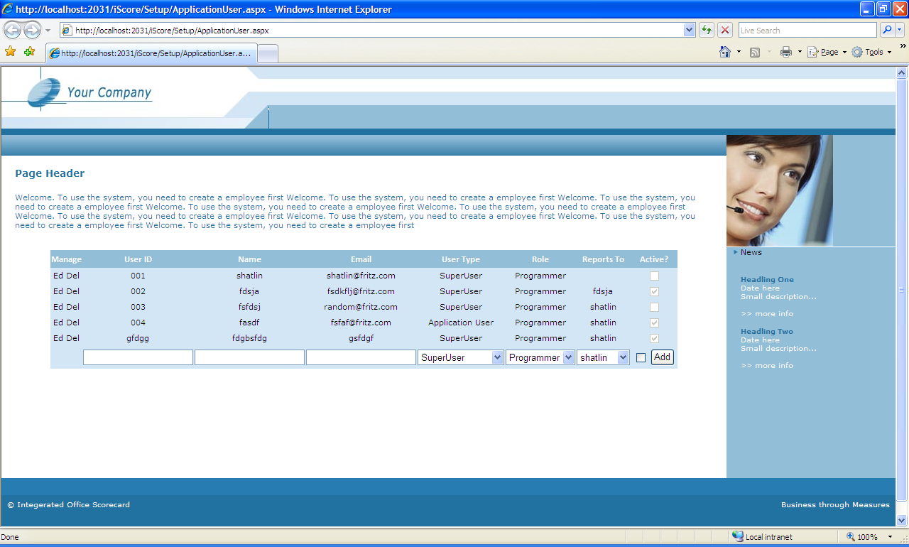

- There is a section called page header, which will contain information about the page
- Below the header the controls will be shown, which the user can interact with
- Any further operations from the controls, or showing information will be done in the right side of the page ( the blue side).Here the scoring methods, graphs or charts can be displayed.
- Below each control, a panel will be present, which will display result of operations to the user. It can also display errors or exceptions.
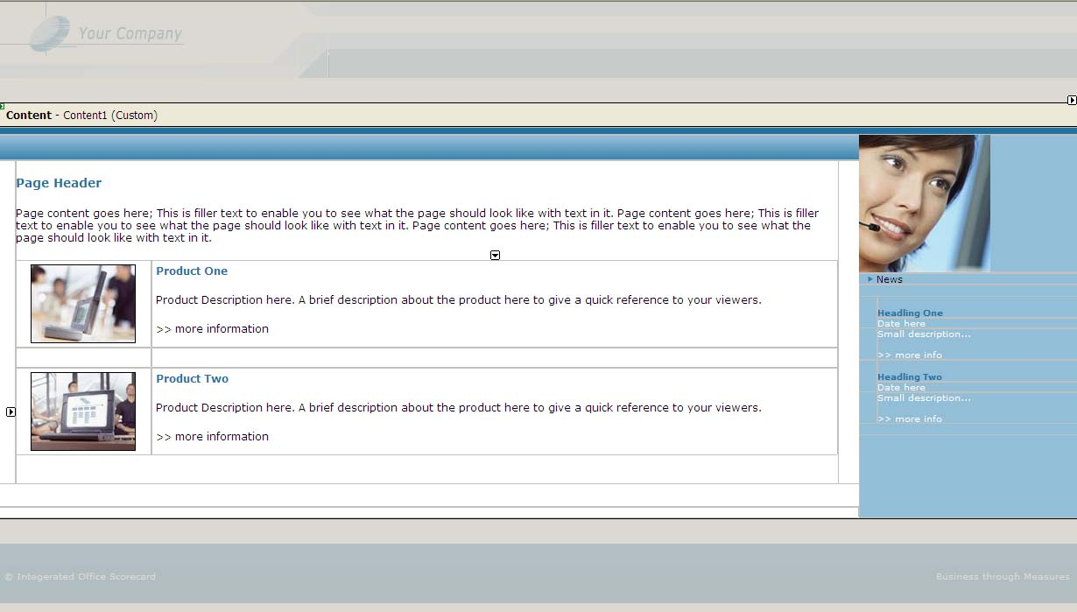
- Each page follows a master page which is designed in a separate file.

If the whole style of the page is to be changed, it should minimally affect individual pages. It should mainly involve changing the styles.

Before starting any page, a template page should be used as the starting point. Then the template can be modified to put in the content

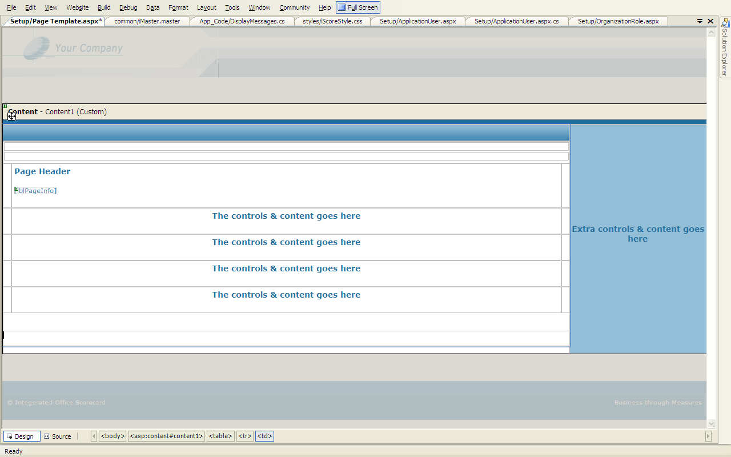

Set Up Sub System

Introduction

The Set up subsystem is divided into three layers. The business logic layer includes the classes and procedures for system prerequisites. Below the business logic layer, the database access layer exists. Business logic layer interacts with the database layer to get the data from the database. The business logic layer will never interact directly with the database directly. It will always request the database layer to get the data. The database layer makes calls to the database and gets or sends the data. Please note that system prerequisites database can be a separate database or exist together with the other subsystems database. Nevertheless, in IOS, this will be a separate database which will be accessed by other systems. Also the business logic layer will work as a web service, serving information to whatever system that requests it.

System Setup

System Setup Database Layer
System Setup business Logic Layer
System SetupDatabase

System Setup Data base Design

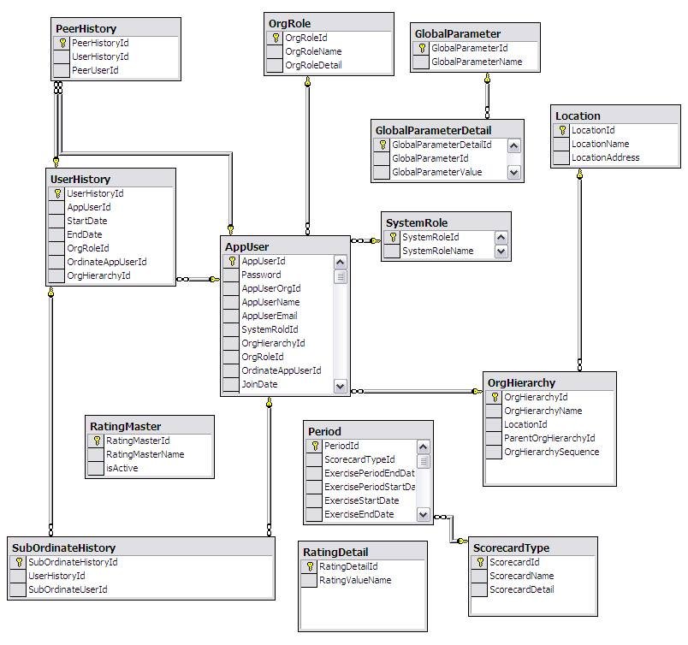
System Setup Pages

Competency management system

Competency management System
Competency Management business logic layer
Competency Management Database
Competency Management Database layer

Competency management Data base Design

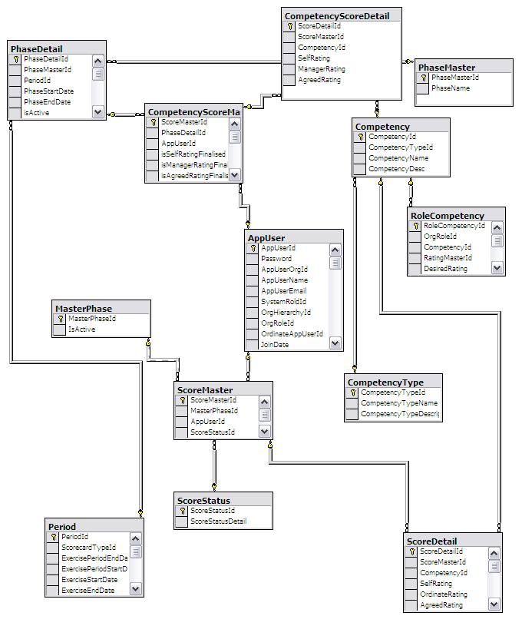
Competency management Pages

Balanced scorecard management system

BS management system

BS management database layer
BS management business logic layer
BS management database

Balanced scorecard Data base Design

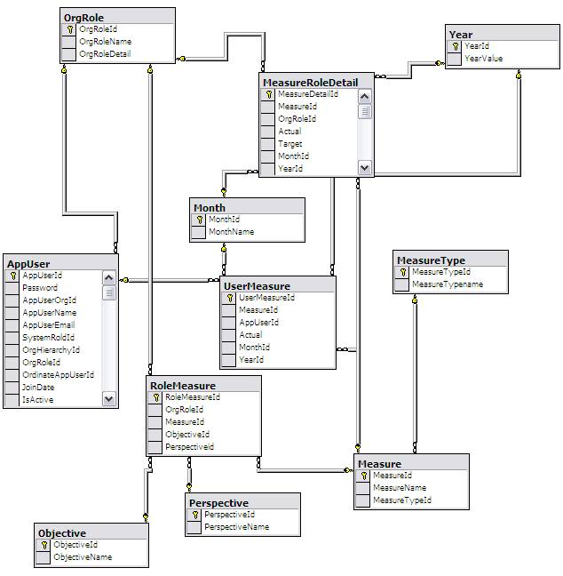
Balanced scorecard Pages

Integration management system

Integration Management System
Integration Management database layer
Integration Management business logic layer
Integration Management database

Integration management Data base Design

Tables required for Integration management are already covered in the separate scorecard

modules.Integration management Web Pages

Performance Management System
Performance Management System
Performance Management Database layer
Performance Management Business Logic Layer
Performance Management Database

Performance Management Data base Design

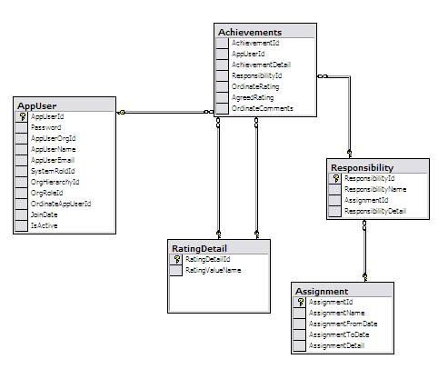
Performance Management Pages

Development Architecture
The development for IOS is done in a layered approach, as per the recommendations from Microsoft.
layered architecture is based on three layers: presentation, business, and data.

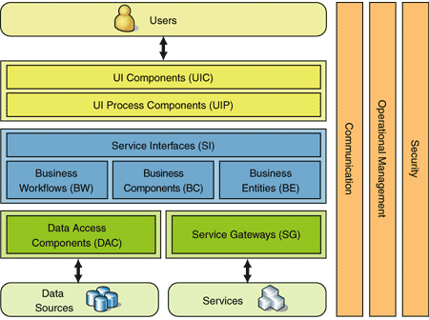
Figure 1: Three-Layered Services Application
The three layers are:
- Presentation. The presentation layer provides the application's user interface (UI). Typically, this involves the use of Windows Forms for smart client interaction, and ASP.NET technologies for browser-based interaction.
- Business. The business layer implements the business functionality of the application. The domain layer is typically composed of a number of components implemented using one or more .NET - enabled programming languages. These components may be augmented with Microsoft .NET Enterprise Services for scalable distributed component solutions and Microsoft BizTalk Server for workflow orchestration.
- Data The data layer provides access to external systems such as databases. The primary .NET technology involved at this layer is ADO.NET. However, it is not uncommon to use some .NET XML capabilities here as well.

Development Life Cycle
The software uses the incremental model development life cycle. At specified intervals, fully functional versions of the software will be released, with more functionalities that the previous version. In this model we divide products into builds, where section of product are created and tested separately. Here errors are found in requirement phase itself, user feedback is taken for each stage and code is tested after it is written.

Exception Handling
Exception is handled in the presentation layer. At each layer, whenever exception occurs, the exception will be thrown to the calling layer. It will be handled in the presentation layer. Above each control a panel will be present in the UI, which will report the error to the user. If an exception is not handled, the application should redirect the user to a generic error page.

Development Process

the following order is followed while developing a page.

1) View the requirements & write the operations the page need to perform
2) Design the layout of the page
4) Write test cases that the page should pass.
5) Write validations that need to be satisfied.
6) Write the pseudo code functions in presentation; BL and DL (Include the high level comments). Review if it satisfies the coding conventions.
7) Write the actual functions and write error handling routines to the completion
8) Test the page and document the testing.

IOS CONSTRUCTION (DEVELOPMENT)
Introduction
As specified in the design section, IOS is constructed as 3-tier application.

All the database related operations are performed in a seperate project called “Data”.All the rules that are to be applied on the data are maintained in another project called “Business” and the UI, the webpages and controls are maintained in a website project called “Iscore”. The diagram below shows how these projects are files are classied in visual studio.
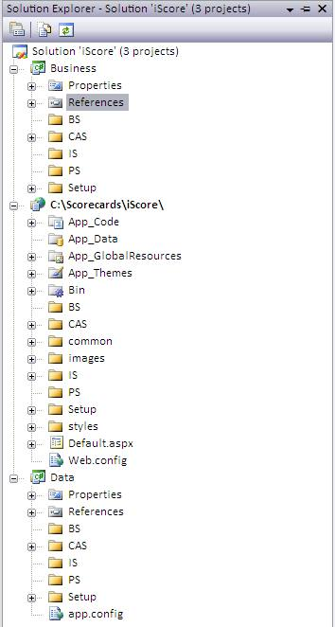
Data Tier
The datatier handles all the calls to the database and the interaction. Business layer or Presentation layer doesnot call database directly. They request the datatier for some data or operation and the data tier executes the operation or get the data from the database.

There are two ways how a datatier is designed. Using custom classes and typed datasets. Custom classes are classes the developer creates to perform all the operations of interacting with the database, while typed datasets are classes that visual studio creates. Usually for most of the time, typed datasets are the best to choose, but at times when there are huge number of relations between tables , they are better done using custom classes. IOS uses both these approaches.

Custom classes used in Data Tier.

To get familiarity with the .NET data access components, a few of the entities were developed as custom classes in the datatier. The diagram below depicts the classes that were developed as custom classes. As shown in the figure, a base class, systemManageDB is created which handles the initialization of Data access components like Connection, Command, Adapter and connectionstring. The child classes inherit from this class and implement their specific functions.

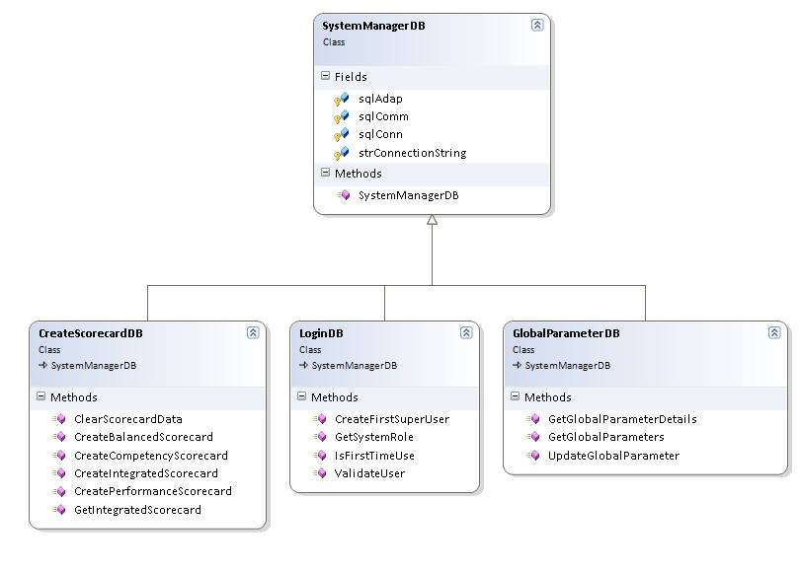

Given below is the sample code for the GlobalParameterDB class.

using System;
using System.Collections.Generic;
using System.Text;
using System.Data.SqlClient;
using System.Data;
/// <summary>
/// Summary description for GlobalParameterDB
/// </summary>
///

namespace Data.Setup
{
public class GlobalParameterDB : SystemManagerDB
{
public static DataSet GetGlobalParameters()
{

DataSet dsGlobalParameters = new DataSet();
sqlComm.CommandText = "Select * From GlobalParameter";
sqlAdap.SelectCommand = sqlComm;
sqlComm.CommandType = CommandType.Text;

try
{
sqlAdap.Fill(dsGlobalParameters);
return dsGlobalParameters;
}
catch (Exception objException)
{

throw new Exception(objException.Message);
}
finally
{
sqlConn.Close();
}

}

public static DataSet GetGlobalParameterDetails(int iGlobalParameterId)
{

DataSet dsGlobalParameters = new DataSet();

sqlComm.CommandText = "Select GlobalParameterDetailId,GlobalParameterValue,Example,Isselected From GlobalParameterDetail where GlobalParameterId= @GlobalParameterId";

try
{
sqlAdap.SelectCommand = sqlComm;
sqlComm.CommandType = CommandType.Text;
sqlAdap.SelectCommand.Parameters.Add("@GlobalParameterId", SqlDbType.Int).Value = iGlobalParameterId;

sqlAdap.Fill(dsGlobalParameters);
return dsGlobalParameters;
}
catch (Exception objException)
{

throw new Exception(objException.Message);
}
finally
{
sqlConn.Close();
}
}

public static void UpdateGlobalParameter(int GlobalParameterDetailId)
{

SqlTransaction sqlTran = sqlConn.BeginTransaction();
try
{
sqlComm.Transaction = sqlTran;
sqlAdap.UpdateCommand = sqlComm;
sqlComm.CommandType = CommandType.Text;
sqlAdap.UpdateCommand.Parameters.Add("@GlobalParameterDetailId", SqlDbType.Int).Value = GlobalParameterDetailId;
sqlComm.CommandText = "Update GlobalParameterDetail set isSelected ='No' where isSelected='Yes' and GlobalParameterId= (select distinct GlobalParameterId from GlobalParameterDetail where GlobalParameterDetailId=@GlobalParameterDetailId)";

sqlComm.ExecuteNonQuery();

sqlAdap.UpdateCommand = sqlComm;
sqlComm.CommandType = CommandType.Text;
sqlComm.CommandText = "Update GlobalParameterDetail set isSelected ='Yes' where GlobalParameterDetailId=@GlobalParameterDetailId";
sqlComm.ExecuteNonQuery();
sqlTran.Commit();
}

catch (Exception objException)
{
sqlTran.Rollback();
throw new Exception(objException.Message);
}
finally
{
sqlConn.Close();
}

}
}

}

Strongly Typed Dataset classes used.

All the remaining classes were developed as strongly typed datasets to leverage the power of visual studio in developing robust datasets that are easy to develop and to maintain. The images below list all the classes of typed datasets and their adapters. Only the important methods are shown for the purpose of simplicity.

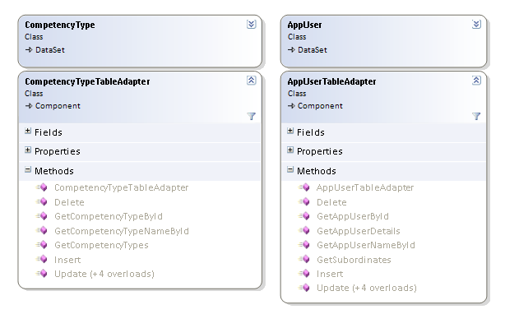

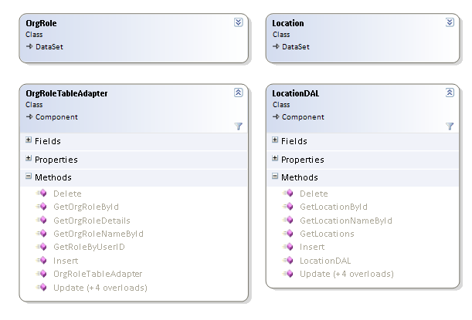

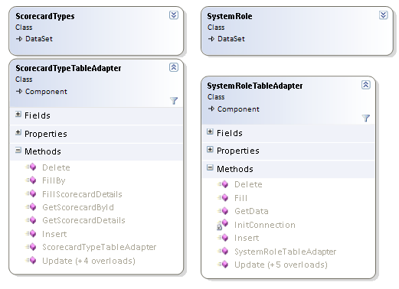

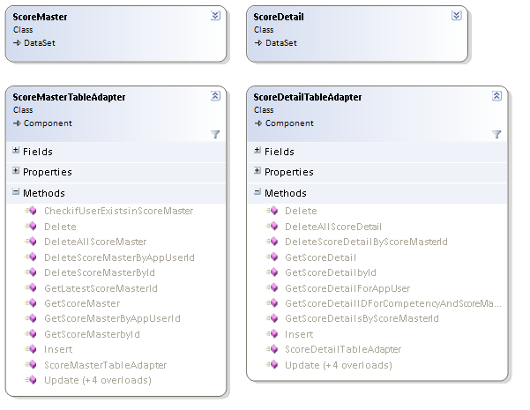
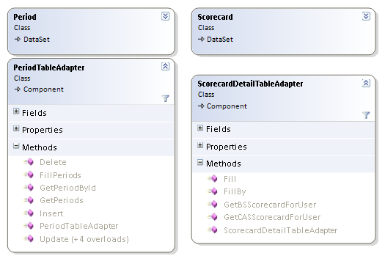
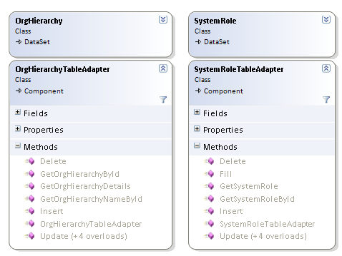
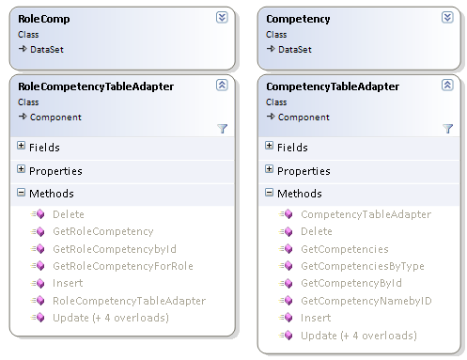

Datasets and the sql queries that populate the functions

Given below is an instance of the datasets described above. This shows the Location Dataset and the sql queries behind each function.

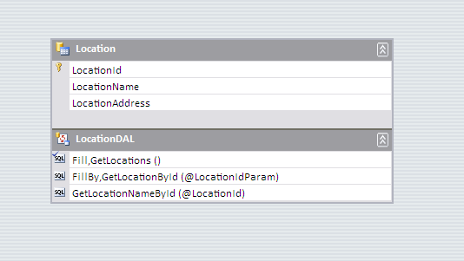
GetLocations
SELECT LocationId, LocationName, LocationAddress FROM Location

GetLocationById
SELECT LocationId, LocationName,LocationAddress FROM Location WHERE (LocationId = @LocationIdParam)

GetLocationNameById
SELECT LocationName FROM Location WHERE (LocationId = @LocationId)

Business Tier
The business tier project contains the logic that builds upon the data tier to manipulate the data. Once it gets the data from data tier, busineess tier might change the data as per the requirements before sending it to the webpages.
Also getting the data or or user inputs from webpages the business tier, might contain methods to pass data to the data tier as parameters so that the datatier does the database operations such as add records, delete records.

Listed below are the classes and the methods in each class.
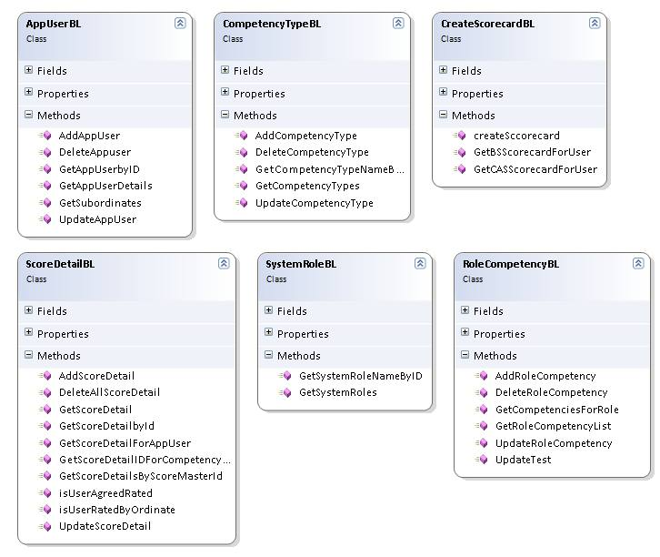

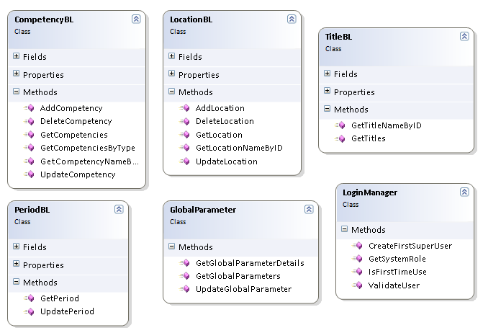

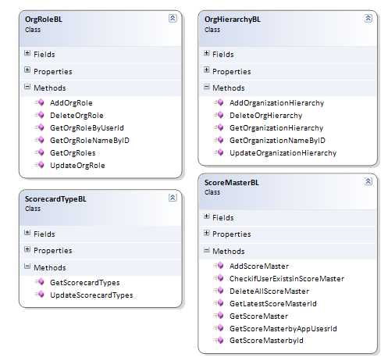
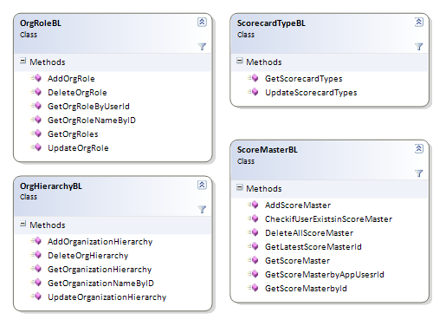
Presentation Tier

This tier contains the webpages of the application in which the users interact with the application. The webpages are aspx pages that use a master page for a common look and feel and themes to easily manage styles of controls. All the messages ( the strings, page names ) are stored in a separate class and accessed in the pages. This is explained below.

// The page that contains all the strings in the application

using System;
using System.Data;
using System.Configuration;
using System.Web;
using System.Web.Security;
using System.Web.UI;
using System.Web.UI.WebControls;
using System.Web.UI.WebControls.WebParts;
using System.Web.UI.HtmlControls;
using System.Collections;
/// <summary>
/// Summary description for DisplayMsgs
/// </summary>
public class MsgColl
{
private static Hashtable MsgHash = new Hashtable();

public MsgColl()
{

}

public enum Msg
{
//login page
LoginTableHeader = 101,
ErrorOccured = 102,
PasswordlengthMustbesix = 103,
PasswordConfirmationMisMatch = 104,
BtnTextCreateEmployee = 105,
BtnTextLogin = 106,
PageLogin = 107,
PageInfoLogin = 108,
LoginFailed = 109,
LoginTableHeaderFirstTimeuse = 110,

//global parameters
PageGlobalParameters = 201,
PageInfoGlobalParameters = 202,

//OrganizationHierarchy
PageInfoOrgHierarchy = 301,
PageInfoOrgHierarchyNoRows = 302,

//ApplicationUser
PageApplicationUser = 401,
PageInfoApplicationUser = 402,

//Location
PageLocation = 501,
PageInfoLocation = 502,

//Scoreacard Types
PageScorecardTypes = 601,
PageInfoScorecardTypes = 602,

//Scoreacard Types
PagePeriod = 701,
PageInfoPeriod = 702,

//Organization Roles
PageOrganizationRole = 801,
PageInfoOrganizationRole = 802,

//Competency Type
PageCompetencyType = 901,
PageInfoCompetencyType = 902,

//Home Page
PageHome = 1001,

// Role Competency

PageRoleCompetency=1101,
PageinfoRoleCompetency=1102,

//Access Deied

PageAccessDeied = 1101,
PageinfoAccessDeied = 1102

}

public static void InitialiseHashTable()
{
//login page
MsgHash.Add(101, "Please enter user name and password");
MsgHash.Add(102, "Error Occured.Please contact Administrator");
MsgHash.Add(103, "Password must be minimum six characters");
MsgHash.Add(104, "Password and confirmation does not match");
MsgHash.Add(105, "Create Employee");
MsgHash.Add(106, "Login");
MsgHash.Add(107, "Login.aspx");
MsgHash.Add(108, "Please enter your username and password to login to the system");
MsgHash.Add(109, "Login Failed. Please try again");
MsgHash.Add(110, "Please create a user name and password ");

//global parameters

MsgHash.Add(201, "GlobalParameters.aspx");
MsgHash.Add(202, "In this page, You can set up the global parameters that will be used through out the system");

//OrganizationHierarchy
MsgHash.Add(301, "The Organization Hierarchy Can be managed Here. You can add, edit , delete Organization Elements");
MsgHash.Add(302, "The Organization Hierarchy Can be managed Here. You can add, edit , delete Organization Elements.Organization Hierachy is not set up yet.Please use the Add Organziation Hierarchy Panel to Add a top level Organization");

//ApplicationUser
MsgHash.Add(401, "ApplicationUser.aspx");
MsgHash.Add(402, "Here the Application users can be managed. Users can be added, User Details can be edited and Users can be removed from the system");
//Location
MsgHash.Add(501, "Location.aspx");
MsgHash.Add(502, "This page is used to manage the locations of the organization");

MsgHash.Add(601, "ScorecardTypes.aspx");
MsgHash.Add(602, "The scorecard Names, their Descriptions can be managed in this page");

MsgHash.Add(701, "Period.aspx");
MsgHash.Add(702, "The scorecard exercise periods, the time duration for which the exercise are done is managed through this period page");

//Organization Roles

MsgHash.Add(801, "OrganizationRole.aspx");
MsgHash.Add(802, " The roles played by the individuals in an orgainzation can be managed here.");

//Competency Type
MsgHash.Add(901, "CompetencyType.aspx");
MsgHash.Add(902, "Competency Types can be managed in this page");

// home page
MsgHash.Add(1001, "home.aspx");

// Role Competency
MsgHash.Add(1101,"RoleComp.aspx");
MsgHash.Add(1102,"Competencies can be assigned to roles in this page.Please select role, competency and the desired rating");

// Access Denied

MsgHash.Add(1201, "AccessDeied.aspx");
MsgHash.Add(1202, "You are not authorized to view this Page. Please Login with the correct rights or use the menu items to use the features you are authorized");
}

public static string GetMsg(Msg enumMsgValue)
{
if (MsgHash.Count == 0)
{
InitialiseHashTable();
}
return (MsgHash[Convert.ToInt32(enumMsgValue)].ToString());
}

}

The strings are accessed in the application using the following style.

lblPageInfo.Text = MsgColl.GetMsg(MsgColl.Msg.PageInfoApplicationUser);

Authentication in the application is done using a basic style.

#region authentication

if (Session["UserType"]==null ||(Convert.ToInt32(UserAutherization.UserType.Administrator) < Convert.ToInt32(Session["UserType"])))
{
Server.Transfer("~/AccessDenied.aspx");
return;
}
#endregion

Page Development

Most of the pages use gridview and object datasources to bind the business logic to the webpages. How this was done is explained in the section below.

- Add a reference to the business layer dll in the website project.
- Drag a objectdatasource control to the webpage.
- Configure the datasource and select the functions for the datasource.
- Assign the datasource to the gridview control.
- Write custom code to implement lower level operations.

The above points are simplified for brevity.There is much more work that needs to be done to make the gridview perform addition of records, editing etc. The following image shows how the pages look in designer.

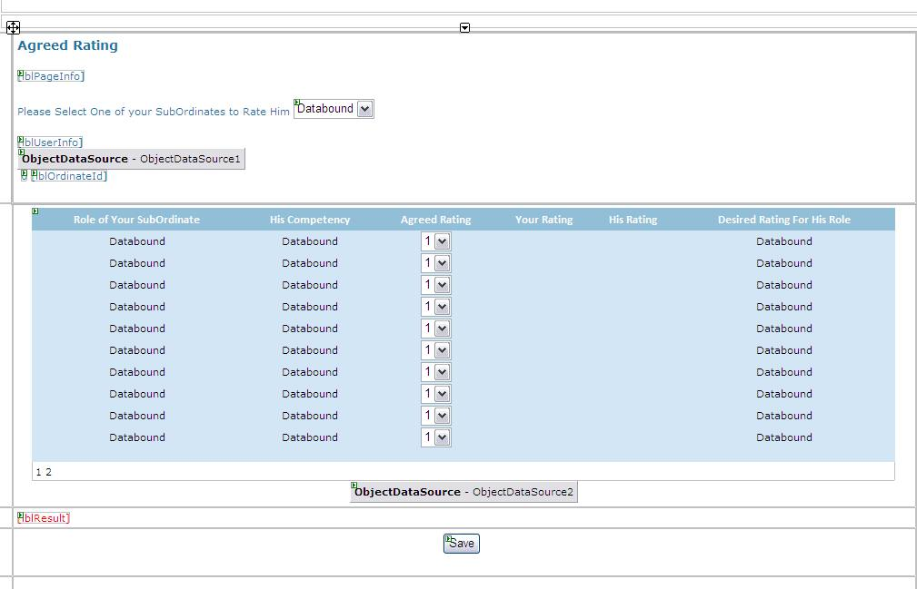

The image below shows the list of files in the set up and CAS modiles

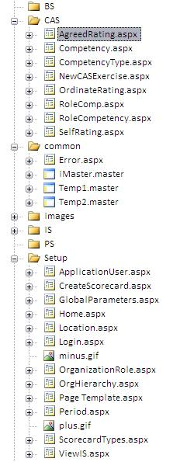

APPENDIX 1

REFERENCES

- "Translating Strategy Into Action: The Balanced Scorecard", by Robert S. Kaplan & David P. Norton. Published 1996. Harvard Business School Press.

- "The Strategy-Focused Organization: How Balanced Scorecard Companies Thrive in the New Business Environment", by Robert S. Kaplan & David P. Norton. Published 2001. Harvard Business School Press

- "Alignment: Using the Balanced Scorecard to Create Corporate Synergies", by Robert S. Kaplan & David P. Norton. Published 2006. Harvard Business School Press.

- HRSG Talent Management System http://www.hrsg.ca/index.php?sctn=4&ctgry=41

- U.S. Office of Personal Management: http://www.opm.gov/employ/html/COMPTNCY.HTM

